BUDGET NEEDS ASSESSMENT APPLICATION

Name of Person Submitting Request: | Marie Mestas; Celia Huston
Program or Service Area: | Library
Division: | Library and Learning Resources Division
When was the last Program Efficacy document completed? | Fall 2009
What rating was given? | Continuation
Amount Requested | $10,000.00

- Provide a rationale for your request.
The Textbook Bank purchases copies of current textbooks for the library Reserve book collections. Students are able to check out textbooks from the Reserve collection to use in the library. This service is of immeasurable value to students who are waiting for financial aid or cannot otherwise afford their textbooks. The continued and increasing need for this service and the higher cost of textbooks has reduced the number and range of titles we can offer. For instance, there are 6 copies of Beginning and Intermediate Algebra to support 27 sections of Math090. Additionally, the Library is unable to support multiple sections of courses where different instructors require different texts.
The Textbook Bank supports the Academic Senate’s resolution to reduce textbook expenses for students by making the textbooks available in the Library. With the almost constant addition of new courses and/or programs on campus, the services of the Textbook Bank are imperative. The heaviest demand for new textbooks is in the fall semester, and if we replace the textbooks damaged by constant use textbooks and purchase duplicate copies of those most often used, we run the risk of having no funds left in our account for spring and summer semester textbook purchases. With the addition of new programs on campus, expanded graduation requirements, and the new, comfortable and highly visible Library, student requests for reserve materials will continue to increase.
Therefore, we request that the Textbook Bank funds be doubled from $10,000 to $20,000 per year.

- Indicate how the content of the EMP One-Sheet and latest Program Efficacy Report support this request. How is the request tied to program planning? (reference the page number(s) where the information can be found on the EMP and Program Efficacy).
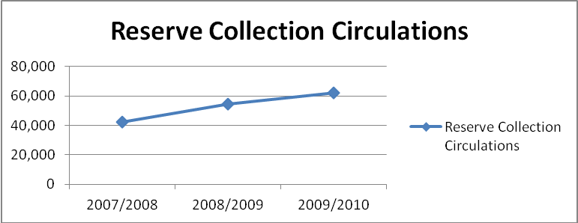The Library and Learning Resources Divisions have not been included in the current Educational Master Plan, but will be included in the next plan update. The Library and Learning Resources Division tracks a variety of statistical data including the number of Reserve Book circulations.

The Library's Reserve Textbook Collection is an extremely well-utilized resource, growing from more than 17,000 circulations (uses) in its first year (1997-98) to well over 42,329 (2007/2008) showing a 148% increase in the first decade of use. Use of the collection continues to grow reaching over 61,000 circulations in 2009/2010.

- Indicate if there is additional information you wish the committee to consider (for example: regulatory information, compliance, updated efficiency and/or student success data or planning etc).
- The current budget allows the Library to support less than 25% of the courses offered on campus based on the SBVC Bookstore’s Booklist.
- There are many departments on campus where the Textbook Bank offers students limited or no textbook support including, but not limited too; Accounting, Architecture, Business, Child Development, Corrections, Computer Information Technology; Nursing, Welding, Electricity/Electronics, Psych Tech, and RTVF.
- Increase in student population from 7,799 FTE’s when the program began in 1997/1998 to 10,102 FTE’s in 2009/2010 without an increase in textbook bank funding.
- The 23% reduction in library hours and service days has impacted textbook use patterns. There is a sense of competition for textbook resources as are more students trying to use fewer textbooks in a reduced timeframe.
- The Textbook Bank is a resource unique to SBVC campus. Students are seldom able to locate required textbooks at public libraries.
- The Library and Learning Resources Division has been approved and ranked for budget augmentation during the last two needs assessment cycles.

- Evaluation of related costs (including any ongoing maintenance or updates) and identification of any alternative or ongoing funding sources. (for example Department Budget, VTEA or Perkins)
Budget increase of $10,000.00 would be ongoing.

- What are the consequences of not funding this budget request?
- There will be fewer textbook resources on campus to serve a growing number of students.
- As prices for textbooks rise each semester, the number of textbooks the Library can purchase for students will become greatly reduced (as it has already each year since 1997, when the Textbook Bank was begun).
- The Library will have to consider reducing the two-hour check out period to one-hour check out period. While this would reduce the amount of time an individual student would have to use the book in the library, it would increase overall student access to textbooks. However, a consequence of this action will be that students will not have sufficient time to study or copy their necessary pages before they must turn over the text to another student. This will cause frustration and stress for the Textbook bank students.

